**Opening a new Vietnamese restaurant in NYC**

**Trang Nguyen**

# Introduction

# Background

# The U.S population is becoming more and more diverse, with an increase of Asian people coming to the big city. New York City is one of them. In these cities, not only the demand for Asian restaurants are increasing with the arrival of more Asian, but as Asian cuisine becomes more popular, the potential for an Asian restaurant to grow is at all-time high.

# Problem

# Opening a Vietnamese restaurant in NYC sounds easy. However, since business is doing well, the competition is also at all-time high. The Capstone will deal with the question of where I should open a Vietnamese restaurant in NYC to have large access to diners, while being able to lower competition.

# Interest

# My mother has always wanted to own a small restaurant when she retires. She had been to a culinary school, and she is a great cook in general. I hope this Capstone could give her some insight on where to start her business.

# Data Acquisition and Cleaning

There are 5 boroughs and 306 neighborhoods in New York City. For this project, a dataset that contains the 5 boroughs and the neighborhoods that exist in each borough as well as the the latitude and longitude coordinates of each neighborhood, is used. [Then the Foursquare API is utilized to explore and segment the neighborhoods](https://geo.nyu.edu/catalog/nyu_2451_34572) [based on the density of existing Vietnamese restaurants in each neighborhood.](https://geo.nyu.edu/catalog/nyu_2451_34572)

([https://geo.nyu.edu/catalog/nyu_2451_34572)](https://geo.nyu.edu/catalog/nyu_2451_34572)

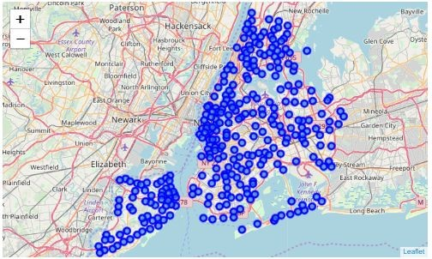

**Figure 1: The map of New York City with neighborhoods superimposed on top**

# Methodology

First the dataset is downloaded, then converted into data frame format with names of boroughs, neighborhoods, their corresponding latitudes & longitudes. The data frame has 5 boroughs and 306 neighborhoods. Then Foursquare API is used to get the list of top 100 venues in each neighborhood (radius = 500m). Only information about the number of restaurants and the number of Vietnamese restaurants is extracted to create a new data frame.

Finally, the new data frame is visualized using scatter plot by matplotlib. A list of recommended neighborhoods where my mother should open her new restaurant is also presented and highlighted with red circle marker on map using folium.

# Results

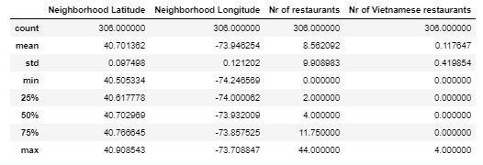

## Figure 2: Basic statistic for the number of restaurants in New York City

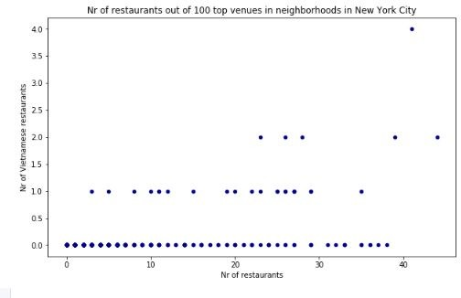

**Figure 3: Scatter plot of the number of restaurants in New York City**

As we can see from the scatter plot and statistic above, most of neighborhoods in New York city do not have any Vietnamese restaurant in their top 100 venues. Besides, in some neighborhoods, the competition among restaurants in general is fiercer than in the rest due to higher density.

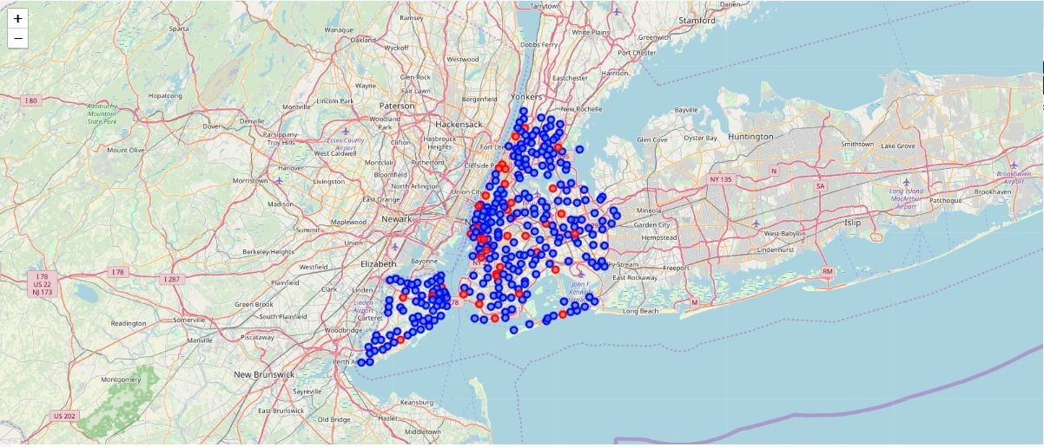

## Figure 4: The map of New York City with neighborhoods superimposed on top. The red markers highlight the recommended neighborhoods where the owner should open his new restaurant

1. **Discussion**

Since many neighborhoods in New York City do not have any Vietnamese restaurant in their top 100 venues, it would be a great business opportunity to open a restaurant here. We should also consider the competition on the market by excluding all neighborhoods that already have too many famous restaurants (>30) and the ones that have too few restaurants as top venues as the need of eating out seems to be low (<10). In short, I would recommend a list of neighborhoods that have no Vietnamese restaurant and have from 10 to 20 other restaurants in top 100 venues.

The list includes 37 neighborhoods, namely 'Kingsbridge', 'Pelham Bay', 'Brighton Beach', 'Gowanus', 'Cypress Hills', 'Bath Beach', 'Boerum Hill', 'Prospect Lefferts Gardens', 'Prospect Park South', 'East Williamsburg', 'Fort Hamilton', 'Inwood', 'Hamilton Heights', 'Manhattanville', 'Central Harlem', 'East Harlem', 'Lincoln Square', 'Soho', 'Battery Park City', 'Howard Beach', 'Long Island City', 'Sunnyside', 'Ridgewood', 'Rego Park', 'College Point', 'Rockaway Beach', 'Queensboro Hill', 'Ravenswood', 'Stapleton', 'Eltingville', 'Ditmas Park', 'Bulls Head', 'Mill Basin', 'Jamaica Hills', 'Fulton Ferry', 'Dumbo', 'Hudson Yards'

# Conclusion

In short, if my mother wants to open a new Vietnamese restaurant in New York City, she can choose one from 37 neighborhoods where there is no Vietnamese restaurant, the need of eating out is relatively high, and the competition on the market is relatively low.